Neutrality Boosts Chaos in Food-webs

*Some elements for the introduction, abstract and discussion of Pablo’s paper on neutrality and chaos (from marten)*

**Abstract**

Near-neutrality of competition has been proposed to facilitate coexistence of species because it slows down competitive exclusion, thus making it easier for equalizing mechanisms to maintain diverse communities. An unrelated line of work has shown that chaos can promote coexistence of many species in ‘super-saturated’ communities. Here we link those previously unrelated findings demonstrating that near neutrality promotes the chances of chaotic dynamics driven by interactions with natural enemies. Our results suggest that near neutrality may promote biodiversity in two ways: through reducing the rates of competitive displacement and more indirectly through promoting non-equilibrium dynamics.

**Introduction**

Ever since Darwin, the idea that species must be sufficiently different to be able to coexist is deeply rooted in the history of biological thinking. Indeed, the principle of competitive exclusion is intuitively straightforward, and elegant mathematical underpinning 1 helped making it one of the cornerstones of ecological theory. Nevertheless, on a closer examination, natural communities often seem to harbor far more species that may be reasonably explained from niche separation. Plankton communities where many species co-exist with little room for differentiation have served as an early example 2,3, inspiring the legendary ecologist G. Evelyn Hutchinson to ask the simple but fundamental question “why are there so many kinds of animals?”3. Since then many mechanisms have been shown to help similar species co-exist. As Hutchinson already proposed himself, fluctuations in conditions may prevent reaching equilibrium at which species would be outcompeted. Also, natural enemies including pests and parasites tend to attack the abundant species more than rare species, and such a ‘kill the winner’ 4 mechanism promotes diversity by preventing one species to take all the resources and outcompete the rest.

In the extensive literature on mechanisms that can prevent competitive exclusion there are two newcomers that radically different from the rest and have created quite a stir: *neutrality* and *chaos*. The neutral theory of biodiversity proposed by Hubbell 5 proposes that species that are entirely equivalent can co-exist in a neutral way because none is able to outcompete the other. The concept of completely equivalent species has met skepticism as it is incompatible with the idea that all species are different. However, it turns out that also ‘near-neutrality’ arises robustly in models of competition and evolution and may boost the chances for co-existence 6-9. Support for such near-neutrality has been found in a wide range of communities 6,10-13. The second relatively new and controversial mechanism that may prevent competitive exclusion is ‘super-saturated co-existence’ in communities that display chaotic dynamics 14. This is in a sense analogous to the prevention of competitive exclusion in fluctuating environments, except that deterministic chaos may arise in autonomous non-linear systems without any external perturbation. Although there has been much debate about the question whether such internally driven complex dynamics plays an important role in ecosystems, several studies support the idea that chaos can be an essential ingredient of natural dynamics (REFS).

Surprisingly, while the potential roles of chaos and neutrality have been intensely debated, no studies seem to have explored how these two fundamental drivers of diversity could be causally related. Here we address this question using simple food-web models. We vary the level of neutrality in the competition between prey species and analyze its effect on the likelihood of generating chaotic dynamics.

**Discussion**

….

End with something strong such as:

Our results suggest a fundamentally new way in which near-neutrality may promote biodiversity. In addition to weakening the forces of competitive exclusion 7, our analyses reveal that near neutrality may boost the chances for chaotic dynamics. As chaos in turn may facilitate super-saturated co-existence, our findings point to a potentially widespread mechanism of maintaining biodiversity.

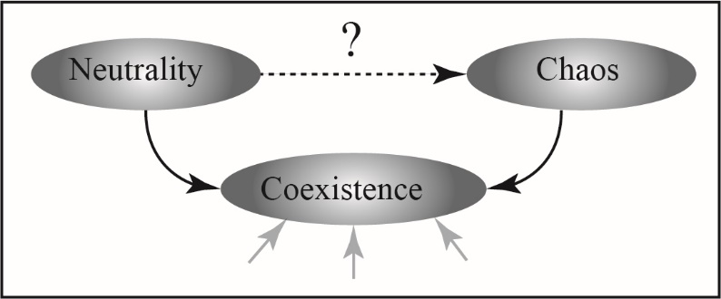

Perhaps think of an illustration? This one is just for inspiration…

1 MacArthur, R. H. & Levins, R. Limiting similarity, convergence and divergence of coexisting species. *American Naturalist* **101**, 377-385 (1967).

2 Hutchinson, G. E. The paradox of the plankton. *American Naturalist* **95**, 137-145 (1961).

3 Hutchinson, G. E. Homage to Santa-Rosalia or why are there so many kinds of animals? *American Naturalist* **93**, 145-159 (1959).

4 Winter, C., Bouvier, T., Weinbauer, M. G. & Thingstad, T. F. Trade-offs between competition and defense specialists among unicellular planktonic organisms: the “killing the winner” hypothesis revisited. *Microbiology and Molecular Biology Reviews* **74**, 42-57 (2010).

5 Hubbell, S. P. *The Unified Neutral Theory of Biodiversity and Biography*. Vol. 32 (Princeton University Press, 2001).

6 Scheffer, M. & Van Nes, E. H. Self-organized similarity, the evolutionary emergence of groups of similar species. *Proceedings of the National Academy of Science of the United States of America* **103**, 6230-6235 (2006).

7 Scheffer, M., van Nes, E. H. & Vergnon, R. Toward a unifying theory of biodiversity. *Proceedings of the National Academy of Sciences*, 201721114 (2018).

8 Fort, H., Scheffer, M. & van Nes, E. H. The paradox of the clumps mathematically explained. *Theoretical Ecology* **2**, 171-176 (2009).

9 Fort, H., Scheffer, M. & Van Nes, E. H. The clumping transition in niche competition: A robust critical phenomenon. *Journal of Statistical Mechanics: Theory and Experiment* **2010**, P05005 (2010).

10 Vergnon, R., Leijs, R., van Nes, E. H. & Scheffer, M. Repeated parallel evolution reveals limiting similarity in subterranean diving beetles. *American Naturalist* **182**, 67-75 (2013).

11 Scheffer, M. *et al.* The Evolution of Functionally Redundant Species; Evidence from Beetles. *PLoS ONE* **10**, e0137974 (2015).

12 Segura, A. M. *et al.* Competition drives clumpy species coexistence in estuarine phytoplankton. *Scientific Reports* **3** (2013).

13 Vergnon, R., Van Nes, E. H. & Scheffer, M. Emergent neutrality leads to multimodal species abundance distributions. *Nature Communications* **3**, 663 (2012).

14 Huisman, J. & Weissing, F. J. Biodiversity of plankton by species oscillations and chaos. *Nature* **402**, 407-410 (1999).